# **Python Dictionary**

**Dictionary** in Python is an unordered collection of data values, used to store data values like a map, which, unlike other Data Types that hold only a single value as an element, Dictionary holds **key:value** pair. Key-value is provided in the dictionary to make it more optimized.

**Note –** Keys in a dictionary don’t allow Polymorphism.

----------X-----------X----------

Polymorphism is a concept that will be explained later in this course. It is a part of Object oriented programming.

----------------------------------

***Disclamer:*** *It is important to note that Dictionaries have been modified to maintain insertion order with the release of Python 3.7, so they are now ordered collection of data values.*

## **Creating a Dictionary**

In Python, a Dictionary can be created by placing a sequence of elements within curly **{}** braces, separated by ‘comma’. Dictionary holds pairs of values, one being the Key and the other corresponding pair element being its **Key:value**. Values in a dictionary can be of any data type and can be duplicated, whereas keys can’t be repeated and must be *immutable*.

**Note –** Dictionary keys are case sensitive, the same name but different cases of Key will be treated distinctly.

| # Creating a Dictionary  # with Integer Keys  Dict = {1: 'Geeks', 2: 'For', 3: 'Geeks'}  print("\nDictionary with the use of Integer Keys: ")  print(Dict)    # Creating a Dictionary  # with Mixed keys  Dict = {'Name': 'Geeks', 1: [1, 2, 3, 4]}  print("\nDictionary with the use of Mixed Keys: ")  print(Dict) |
| --- |

**Output:**

Dictionary with the use of Integer Keys:

{1: 'Geeks', 2: 'For', 3: 'Geeks'}

Dictionary with the use of Mixed Keys:

{1: [1, 2, 3, 4], 'Name': 'Geeks'}

Dictionary can also be created by the built-in function dict(). An empty dictionary can be created by just placing curly braces{}.

| # Creating an empty Dictionary  Dict = {}  print("Empty Dictionary: ")  print(Dict)    # Creating a Dictionary  # with dict() method  Dict = dict({1: 'Geeks', 2: 'For', 3:'Geeks'})  print("\nDictionary with the use of dict(): ")  print(Dict)    # Creating a Dictionary  # with each item as a Pair  Dict = dict([(1, 'Geeks'), (2, 'For')])  print("\nDictionary with each item as a pair: ")  print(Dict) |
| --- |

**Output:**

Empty Dictionary:

{}

Dictionary with the use of dict():

{1: 'Geeks', 2: 'For', 3: 'Geeks'}

Dictionary with each item as a pair:

{1: 'Geeks', 2: 'For'}

### **Nested Dictionary:**

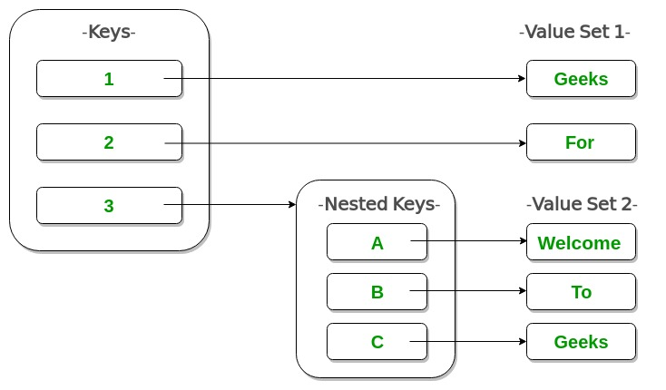

| # Creating a Nested Dictionary  # as shown in the below image  Dict = {1: 'Geeks', 2: 'For',  3:{'A' : 'Welcome', 'B' : 'To', 'C' : 'Geeks'}}    print(Dict) |
| --- |

**Output:**

{1: 'Geeks', 2: 'For', 3: {'A': 'Welcome', 'B': 'To', 'C': 'Geeks'}}

## **Adding elements to a Dictionary**

In Python Dictionary, the Addition of elements can be done in multiple ways. One value at a time can be added to a Dictionary by defining value along with the key e.g. Dict[Key] = ‘Value’. Updating an existing value in a Dictionary can be done by using the built-in **update()** method. Nested key values can also be added to an existing Dictionary.

**Note-** While adding a value, if the key-value already exists, the value gets updated otherwise a new Key with the value is added to the Dictionary.

| # Creating an empty Dictionary  Dict = {}  print("Empty Dictionary: ")  print(Dict)    # Adding elements one at a time  Dict[0] = 'Geeks'  Dict[2] = 'For'  Dict[3] = 1  print("\nDictionary after adding 3 elements: ")  print(Dict)    # Adding set of values  # to a single Key  Dict['Value_set'] = 2, 3, 4  print("\nDictionary after adding 3 elements: ")  print(Dict)    # Updating existing Key's Value  Dict[2] = 'Welcome'  print("\nUpdated key value: ")  print(Dict)    # Adding Nested Key value to Dictionary  Dict[5] = {'Nested' :{'1' : 'Life', '2' : 'Geeks'}}  print("\nAdding a Nested Key: ")  print(Dict) |
| --- |

**Output:**

Empty Dictionary:

{}

Dictionary after adding 3 elements:

{0: 'Geeks', 2: 'For', 3: 1}

Dictionary after adding 3 elements:

{0: 'Geeks', 2: 'For', 3: 1, 'Value_set': (2, 3, 4)}

Updated key value:

{0: 'Geeks', 2: 'Welcome', 3: 1, 'Value_set': (2, 3, 4)}

Adding a Nested Key:

{0: 'Geeks', 2: 'Welcome', 3: 1, 5: {'Nested': {'1': 'Life', '2': 'Geeks'}}, 'Value_set': (2, 3, 4)}

## **Accessing elements from a Dictionary**

In order to access the items of a dictionary refer to its key name. Key can be used inside square brackets.

| # Python program to demonstrate  # accessing a element from a Dictionary    # Creating a Dictionary  Dict = {1: 'Geeks', 'name': 'For', 3: 'Geeks'}    # accessing a element using key  print("Accessing a element using key:")  print(Dict['name'])    # accessing a element using key  print("Accessing a element using key:")  print(Dict[1]) |
| --- |

**Output:**

Accessing a element using key:

For

Accessing a element using key:

Geeks

There is also a method called [**get()**](https://www.geeksforgeeks.org/get-method-dictionaries-python/) that will also help in accessing the element from a dictionary.

* Python3

| # Creating a Dictionary  Dict = {1: 'Geeks', 'name': 'For', 3: 'Geeks'}    # accessing a element using get()  # method  print("Accessing a element using get:")  print(Dict.get(3)) |
| --- |

**Output:**

Accessing a element using get:

Geeks

----------------X-----------------------X

What is the difference between the get function and using the square brackets to get the value from the dictionary?

We will take as example the following input.  
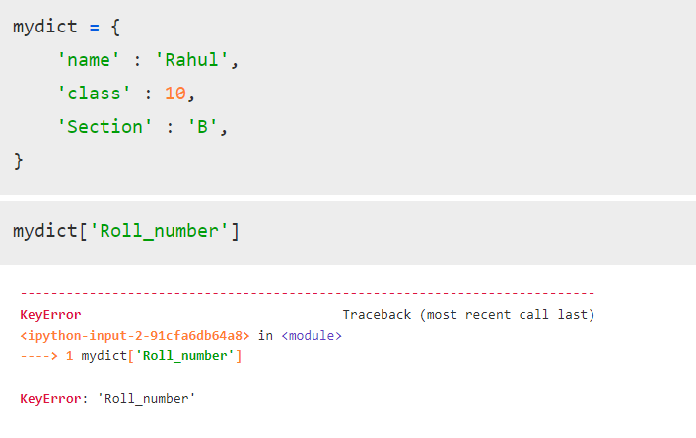

Assume the key you are trying to access does not exist in the dictionary.

In this scenario, if we type the key value in the square brackets, it will throw an error like above.

However If we use the get function, instead of throwing an error, the function will not throw an error or will return anything that we want it to return.

For example, we will take the same case as above.

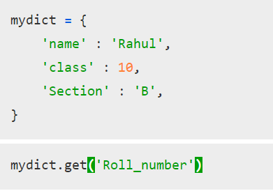

After running these two cells, no output was obtained. We can also get the function to return 0 or any other string.

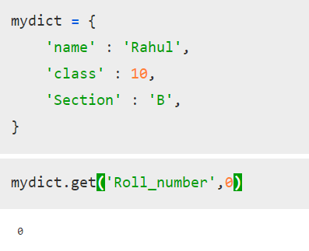

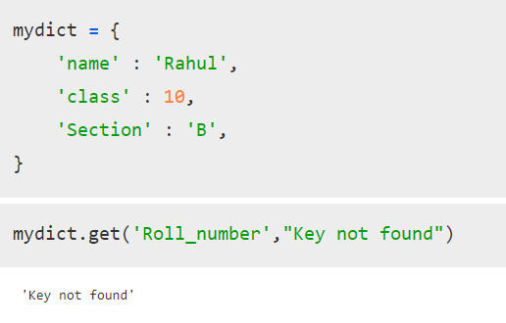

-----------------------------------

### **Accessing an element of a nested dictionary**

In order to access the value of any key in the nested dictionary, use indexing [] syntax

| # Creating a Dictionary  Dict = {'Dict1': {1: 'Geeks'},  'Dict2': {'Name': 'For'}}    # Accessing element using key  print(Dict['Dict1'])  print(Dict['Dict1'][1])  print(Dict['Dict2']['Name']) |
| --- |

**Output:**

{1: 'Geeks'}

Geeks

For

## **Removing Elements from Dictionary**

### **Using del keyword**

In Python Dictionary, deletion of keys can be done by using the **del** keyword. Using the del keyword, specific values from a dictionary as well as the whole dictionary can be deleted. Items in a Nested dictionary can also be deleted by using the del keyword and providing a specific nested key and particular key to be deleted from that nested Dictionary.

**Note:** The **del Dict** will delete the entire dictionary and hence printing it after deletion will raise an Error.

* Python3

| # Initial Dictionary  Dict = { 5 : 'Welcome', 6 : 'To', 7 : 'Geeks',  'A' : {1 : 'Geeks', 2 : 'For', 3 : 'Geeks'},  'B' : {1 : 'Geeks', 2 : 'Life'}}  print("Initial Dictionary: ")  print(Dict)    # Deleting a Key value  del Dict[6]  print("\nDeleting a specific key: ")  print(Dict)    # Deleting a Key from  # Nested Dictionary  del Dict['A'][2]  print("\nDeleting a key from Nested Dictionary: ")  print(Dict) |
| --- |

**Output:**

Initial Dictionary:

{'A': {1: 'Geeks', 2: 'For', 3: 'Geeks'}, 'B': {1: 'Geeks', 2: 'Life'}, 5: 'Welcome', 6: 'To', 7: 'Geeks'}

Deleting a specific key:

{'A': {1: 'Geeks', 2: 'For', 3: 'Geeks'}, 'B': {1: 'Geeks', 2: 'Life'}, 5: 'Welcome', 7: 'Geeks'}

Deleting a key from Nested Dictionary:

{'A': {1: 'Geeks', 3: 'Geeks'}, 'B': {1: 'Geeks', 2: 'Life'}, 5: 'Welcome', 7: 'Geeks'}

### **Using pop() method**

[Pop(](https://www.geeksforgeeks.org/python-dictionary-pop-method/)) method is used to return and delete the value of the key specified.

* Python3

| # Creating a Dictionary  Dict = {1: 'Geeks', 'name': 'For', 3: 'Geeks'}    # Deleting a key  # using pop() method  pop_ele = Dict.pop(1)  print('\nDictionary after deletion: ' + str(Dict))  print('Value associated to poped key is: ' + str(pop_ele)) |
| --- |

**Output:**

Dictionary after deletion: {3: 'Geeks', 'name': 'For'}

Value associated to poped key is: Geeks

### **Using popitem() method**

The popitem() returns and removes an arbitrary element (key, value) pair from the dictionary.

* Python3

| # Creating Dictionary  Dict = {1: 'Geeks', 'name': 'For', 3: 'Geeks'}    # Deleting an arbitrary key  # using popitem() function  pop_ele = Dict.popitem()  print("\nDictionary after deletion: " + str(Dict))  print("The arbitrary pair returned is: " + str(pop_ele)) |
| --- |

**Output:**

Dictionary after deletion: {3: 'Geeks', 'name': 'For'}

The arbitrary pair returned is: (1, 'Geeks')

### **Using clear() method**

All the items from a dictionary can be deleted at once by using **clear()** method.

* Python3

| # Creating a Dictionary  Dict = {1: 'Geeks', 'name': 'For', 3: 'Geeks'}      # Deleting entire Dictionary  Dict.clear()  print("\nDeleting Entire Dictionary: ")  print(Dict) |
| --- |

**Output:**

Deleting Entire Dictionary:

{}

## **Dictionary Methods**

| Methods | Description |
| --- | --- |
| [copy()](https://www.geeksforgeeks.org/python-dictionary-copy/) | They copy() method returns a shallow copy of the dictionary. |
| [clear()](https://www.geeksforgeeks.org/python-dictionary-clear/) | The clear() method removes all items from the dictionary. |
| [pop()](https://www.geeksforgeeks.org/python-dictionary-pop-method/) | Removes and returns an element from a dictionary having the given key. |
| [popitem()](https://www.geeksforgeeks.org/python-dictionary-popitem-method/) | Removes the arbitrary key-value pair from the dictionary and returns it as tuple. |
| [get()](https://www.geeksforgeeks.org/get-method-dictionaries-python/) | It is a conventional method to access a value for a key. |
| [dictionary_name.values()](https://www.geeksforgeeks.org/python-dictionary-values/) | returns a list of all the values available in a given dictionary. |
| str() | Produces a printable string representation of a dictionary. |
| [update()](https://www.geeksforgeeks.org/python-dictionary-update-method/) | Adds dictionary dict2’s key-values pairs to dict |
| [setdefault()](https://www.geeksforgeeks.org/python-dictionary-setdefault-method/) | Set dict[key]=default if key is not already in dict |
| [keys()](https://www.geeksforgeeks.org/python-dictionary-keys-method/) | Returns list of dictionary dict’s keys |
| [items()](https://www.geeksforgeeks.org/python-dictionary-items-method/) | Returns a list of dict’s (key, value) tuple pairs |
| [has_key()](https://www.geeksforgeeks.org/python-dictionary-has_key/) | Returns true if key in dictionary dict, false otherwise |
| [fromkeys()](https://www.geeksforgeeks.org/python-dictionary-fromkeys-method/) | Create a new dictionary with keys from seq and values set to value. |
| [type()](https://www.geeksforgeeks.org/python-type-function/) | Returns the type of the passed variable. |
| [cmp()](https://www.geeksforgeeks.org/dictionary-methods-in-python-set-1-cmp-len-items/) | Compares elements of both dict. |